**Comprehensive assessment of breast health and cancer awareness understanding symptom recognition and breast self-examination among women in India, Malaysia, and Africa.**

**Tiwari Santosh1**, **Ghassan Salibi2, Nikolaos Tzenios3**

1 Kursk StateMedical. University

123 Charisma University

**Abstract**

**Background**: Breast cancer is the most common cancer in women worldwide, with 2.3 million new cases and 670,000 deaths reported in 2022. Early detection through breast health awareness, symptom recognition, and breast self-examination (BSE) is critical, particularly in low-resource settings. This study examines breast health knowledge and BSE practices among women in India, Malaysia, and Africa.

**Materials and Methods**: A cross-sectional online survey was conducted among 69 reproductive-aged women (18–45 years) from India, Malaysia, and Africa, primarily students at Kursk State Medical University. The questionnaire assessed demographics, menstrual history, family history, awareness of breast cancer risk factors and symptoms, and BSE practices.

**Results**: Significant regional variations were observed. African women reported higher use of imaging investigations and oral contraceptives but also experienced earlier menarche and frequent breast pain. Malaysian women had the highest prevalence of irregular menstrual cycles and identified more lumps during BSE. Indian women demonstrated greater awareness of BSE but lower adherence to regular practice. Socioeconomic status, cultural beliefs, and healthcare access strongly influenced breast health behaviors across regions.

**Conclusion:** The findings underscore disparities in breast health awareness and BSE practices across different populations. Culturally tailored education, community-based interventions, and improved access to preventive services are needed to close gaps in awareness and practice. Empowering women with knowledge and resources can support earlier detection and better outcomes in breast cancer care.

**Keywords**: ***Polycystic Ovary Syndrome (PCOS), Health-Related Quality of Life (HRQoL), Metabolic Syndrome, Psychological Distress, Women's Health***

**1.0 Introduction**

Breast cancer remains a significant global health concern, with 670,000 deaths reported worldwide in 2022 alone. It affects women of all ages, with approximately 2.3 million new cases diagnosed annually. Understanding breast health, symptom recognition, and the practice of breast self-examination (BSE) are crucial for early detection and improving outcomes. [1]

Breast cancer is a significant global health concern, with staggering statistics revealing its widespread impact on women worldwide. In 2022 alone, breast cancer caused approximately 670,000 deaths globally, making it a leading cause of mortality among women. Alarmingly, roughly half of all breast cancers occur in women with no specific risk factors other than their sex and age, highlighting the indiscriminate nature of this disease. Moreover, breast cancer was identified as the most common cancer in women in 157 out of 185 countries in 2022, underlining its pervasive reach across diverse populations. Importantly, breast cancer knows no boundaries, occurring in every country in the world and affecting women at any age after puberty, albeit with increasing rates in later life.[1,2]

These global estimates also reveal striking disparities in breast cancer burden according to human development indices. In countries with very high human development indices, 1 in 12 women will be diagnosed with breast cancer in their lifetime, with 1 in 71 women succumbing to the disease. In stark contrast, in low human development index countries, while only 1 in 27 women is diagnosed with breast cancer, 1 in 48 women will die from it. Female gender remains the strongest risk factor for breast cancer, with approximately 99% of cases occurring in women. However, it is noteworthy that breast cancer also affects men, albeit at a much lower frequency, with approximately 0.5–1% of cases occurring in men.

While certain factors, such as increasing age, obesity, alcohol consumption, and family history of breast cancer, can heighten the risk of developing the disease, approximately half of all breast cancers develop in women with no identifiable risk factors other than their gender and age. Family history of breast cancer, although significant, is not a prerequisite for developing the disease, underscoring the complexity of its etiology. Furthermore, inherited high-penetrance gene mutations, such as those in the BRCA1, BRCA2, and PALB-2 genes, significantly increase breast cancer risk and may warrant risk reduction strategies such as prophylactic surgeries or chemoprevention.

Given the profound impact of breast cancer on women's health and well-being globally, there is an urgent need for research aimed at enhancing early detection, improving treatment outcomes, and addressing disparities in access to care. This study seeks to contribute by examining breast health awareness, symptom recognition, and breast self-examination practices among women in India, Malaysia, and Africa. By elucidating regional variations in breast health knowledge and behaviours, this research aims to inform targeted interventions and promote equitable access to breast cancer prevention and care services across diverse populations.[1,2]

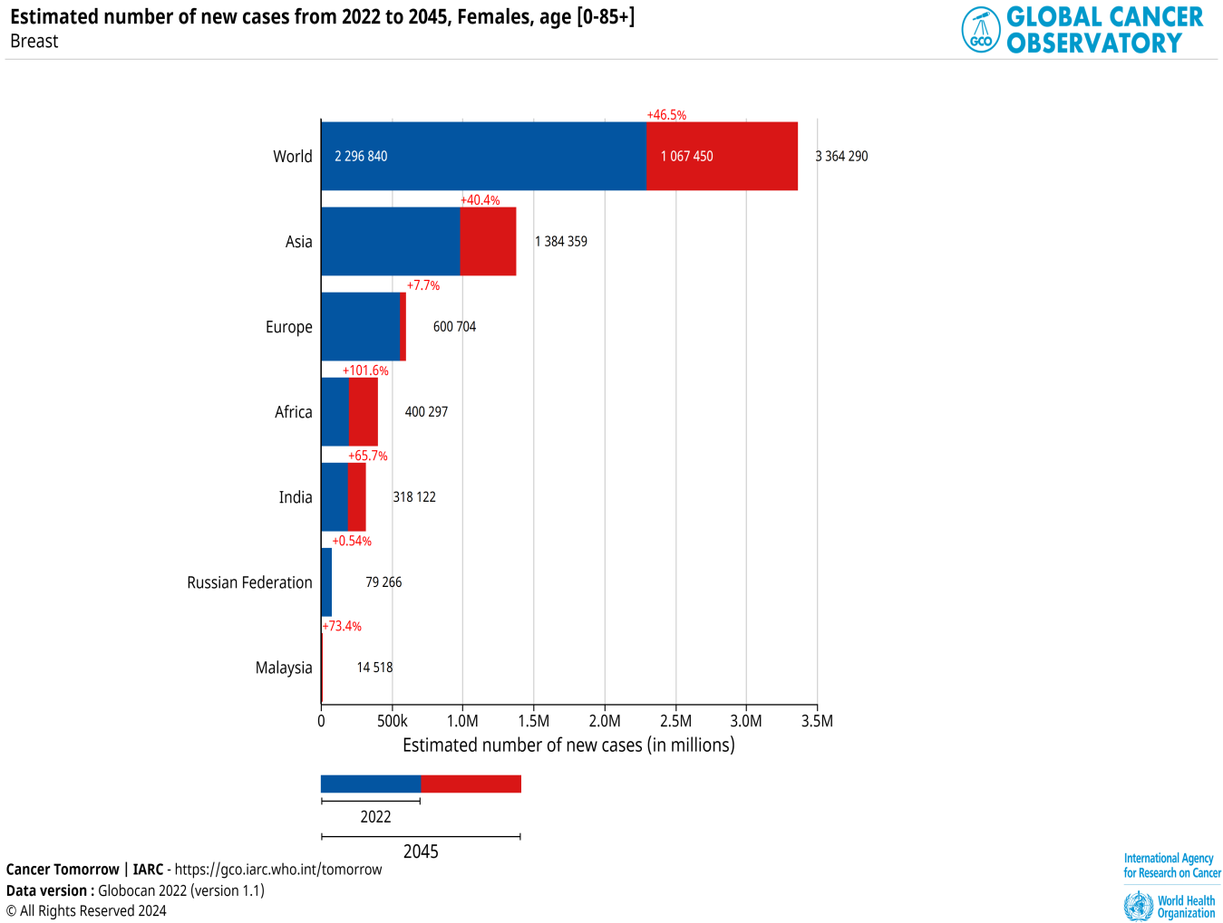

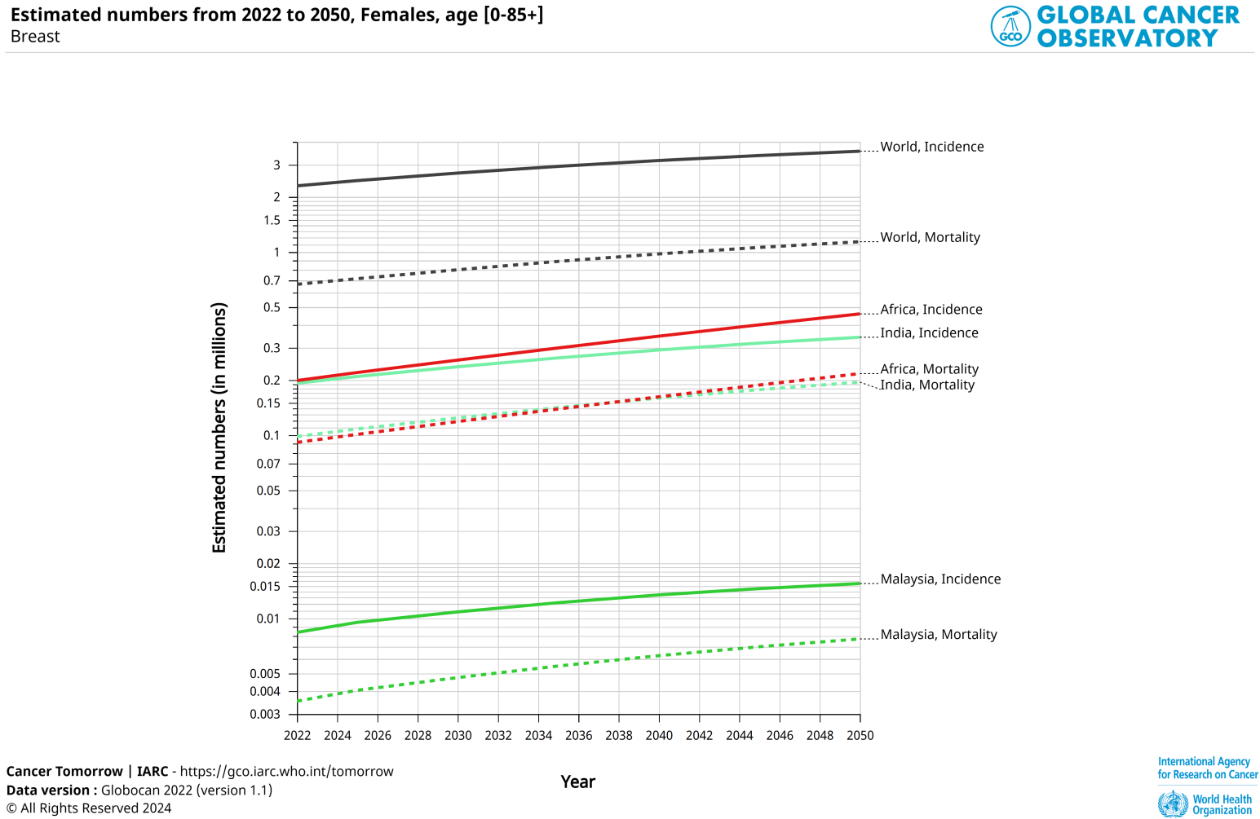

**2.0 Aims, Materials and Methods**

**Purpose of the Study: To** assess breast health awareness and knowledge of breast self-examination among non-pregnant reproductive-aged women from India, Malaysia, and Africa.

**Materials and Methods—**An online survey was designed and conducted to investigate breast health awareness and knowledge of breast self-examination (BSE) among non-pregnant reproductive-aged women from India, Malaysia, and Africa. The survey targeted women aged between 18 and 45, with an average age of 24, primarily female students from KSMU (Kursk State Medical University). A total of 69 participants were recruited for the study.

The survey instrument comprised a series of structured questions covering various aspects related to breast health, including demographics, menstrual history, family history of breast cancer, BSE practices, awareness levels, and pain assessment. Participants were provided with clear instructions on completing the survey, and informed consent was obtained before participation.

Demographic data collected included age, ethnicity, educational background, and geographical location. Menstrual history was assessed by inquiring about the onset of menarche and the regularity of menstrual cycles. Family history of breast cancer was ascertained by asking participants if any first-degree relatives had been diagnosed with the disease.

BSE practices were evaluated by querying participants about their frequency of performing self-examinations, familiarity with BSE techniques, and beliefs regarding its effectiveness for early detection. Awareness levels were assessed through questions to gauge participants' knowledge of breast cancer risk factors, symptoms, and screening modalities.

To assess pain perception during BSE, participants were asked to rate any discomfort or pain experienced using the Wong-Baker Pain Scale, a widely used tool for pain assessment in clinical settings. The scale consists of a series of faces ranging from smiling to crying, with corresponding numerical values from 0 to 10, representing varying levels of pain intensity.

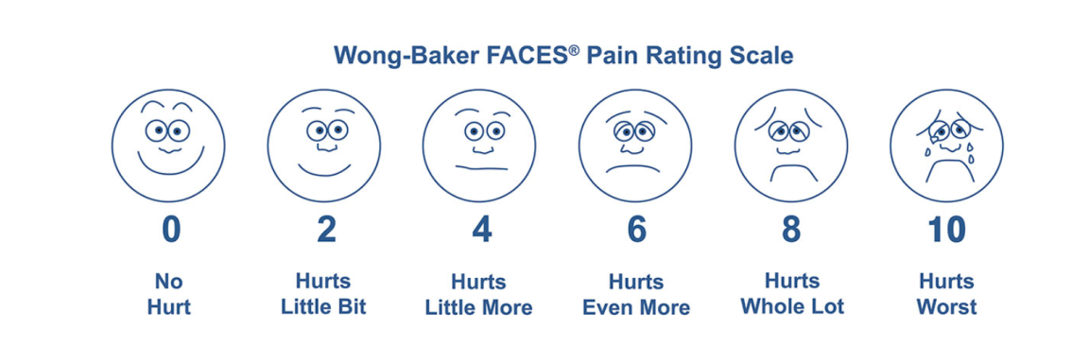

**Inclusion Criteria:**

1. Non-pregnant reproductive-aged women between 18 and 45 years old.
2. Participants from diverse backgrounds residing in India, Malaysia, and Africa.
3. Willingness to participate in the online survey and provide informed consent.
4. Ability to comprehend and respond to survey questions in English.
5. Female students from Kursk State Medical University (KSMU) were primarily included to ensure a consistent demographic representation.

**Exclusion Criteria:**

1. Pregnant women or those currently breastfeeding, as their breast health status may be influenced by physiological changes associated with pregnancy and lactation.
2. Women outside the specified age range of 18 to 45 years, as the study focused on reproductive-aged individuals.
3. Individuals with a history of breast cancer or those undergoing active treatment for breast cancer may have experiences and practices that differ significantly from those of the general population.
4. Participants who are unwilling or unable to provide informed consent for participation in the survey.
5. Non-English speaking individuals, as the survey was conducted in English, to ensure consistency and ease of data collection and analysis.

**3.0 Literature Review**

**3.1 Global burden of breast cancer**

The global burden of breast cancer is substantial, with approximately 2.3 million new cases diagnosed worldwide in 2020, representing about a quarter of all new cancer diagnoses in women. Incidence rates vary significantly across regions, with higher rates observed in Australia/New Zealand, Western Europe, and North America, while lower rates are seen in Asia and Africa. Notably, transitioning countries are experiencing a rapid increase in breast cancer incidence.[5]

Despite advances in treatment, breast cancer remains the leading cause of cancer-related deaths among women globally, with approximately 685,000 deaths reported in 2020. While mortality rates are highest in certain regions such as Melanesia, Western Africa, and the Caribbean, there is less geographical variation compared to incidence rates. Mortality rates are declining in many high-income countries but are increasing in low-income countries.[5,6]

Projections suggest a significant rise in the global burden of breast cancer by 2040, with estimates indicating over 3 million new cases (a 40% increase) and 1 million deaths (a 50% increase) annually. Regions with lower socio-demographic indices (SDI) are expected to bear the largest burden of breast cancer in the future.[6,7]

The escalating incidence rates, particularly in transitioning countries, coupled with the increasing mortality rates in low-income nations, underscore the pressing need for comprehensive breast cancer control strategies worldwide. These strategies should encompass prevention, early detection, and enhanced access to treatment [7, 8].

**3.2 Cultural beliefs and practices related to breast health and cancer awareness**

Cultural beliefs and practices exert significant influence on perceptions of breast health, illness causation, and treatment-seeking behaviours related to breast cancer. Within various cultures, breast cancer is often attributed to supernatural or spiritual forces, such as evil spirits, curses, or divine punishment. Additionally, imbalances in hot/cold elements or disruptions in vital energies are believed to contribute to the onset of the disease. These beliefs can lead to delays in seeking medical treatment.[9]

Before turning to conventional medical care, many individuals rely on traditional healing practices, including consultations with traditional healers, herbal remedies, and participation in spiritual rituals or alternative therapies. For instance, practices like cupping, coining, or the application of herbal or animal-based pastes on breast lumps are common in certain cultural contexts.[10]

Cultural taboos surrounding discussions about breast-related issues, undergoing clinical breast exams conducted by male providers, or exposing breasts during screening procedures like mammograms contribute to the stigma associated with breast cancer in many communities. Consequently, breast cancer is often viewed as a source of shame or social isolation.[9,10]

Strict adherence to cultural norms of female modesty presents a significant barrier to women seeking breast examinations or screening tests that require undressing in front of others. These concerns are particularly pronounced in cultures that prioritize female chastity and family honour. [11]

Fatalistic beliefs about cancer being a death sentence or beyond one's control are prevalent in certain cultures. This fatalistic perspective discourages individuals from engaging in preventive health behaviours such as breast self-exams and cancer screening. [12]

Community outreach initiatives must be employed to address these cultural beliefs and practices, involving respected community leaders and providing culturally tailored breast health education. By doing so, we can improve breast cancer awareness and promote timely screening and treatment within diverse populations.

**3.3  Previous studies on breast health awareness and BSE practices**

**In India:**

* Gadgil et al. conducted a randomized controlled trial implementing an intervention involving annual email brochures, leading to increased breast cancer awareness and timely detection among urban working women.[11]
* Dey et al. implemented a community-based breast cancer awareness program in Delhi, utilizing trained health workers to deliver educational sessions and demonstrations on BSE. This program resulted in enhanced knowledge about breast cancer symptoms and BSE technique among participants.

**Key strategies identified in India:**

* Utilizing existing communication channels like email for awareness campaigns.
* Engaging community health workers for culturally tailored education sessions.
* Demonstrating the BSE technique during interactive sessions.[

**In Malaysia:**

* Akhtari-Zavare et al. conducted a randomized trial evaluating a breast health awareness intervention among young Malaysian women, which involved educational materials and BSE training, resulting in significant improvements in breast cancer knowledge, attitudes, and BSE practice.
* Abdul Aziz et al. found that involving breast cancer survivors as spokespersons helped reduce stigma associated with breast cancer in rural Malaysian communities.

**Key strategies in Malaysia:**

* Tailoring educational materials for specific age/demographic groups.
* Providing hands-on BSE training during interventions.
* Engaging breast cancer survivors in awareness campaigns. [11,12]

**In Africa:**

* A pilot mobile intervention in Bangladesh demonstrated that women attending educational sessions were more likely to seek clinical follow-up for breast abnormalities compared to a control group.
* In Nigeria, a community-based awareness program utilizing audio-visual aids, demonstrations, and interpersonal communication significantly improved breast cancer knowledge and BSE practice.

**Key strategies identified in Africa:**

* Utilizing mobile technology for awareness and screening reminders.
* Employing multiple communication channels like audio-visuals and interpersonal outreach.
* Conducting practical BSE demonstrations during sessions.

Successful interventions across these regions commonly involved culturally tailored educational materials, interactive training on BSE technique, engaging community health workers/survivors, and utilizing diverse communication channels tailored to the target population. A multi-component approach addressing knowledge gaps, stigma, and access barriers is recommended for effective breast health promotion.

**3.4 Impact of socioeconomic status, education level, and urban/rural residence on breast health awareness and BSE practices**

Socioeconomic factors exert a significant influence on breast health awareness, access to healthcare services, and participation in screening programs, leading to pronounced disparities in breast cancer outcomes. Low socioeconomic status (SES) is closely linked to decreased adherence to breast cancer screening, irrespective of race/ethnicity and insurance status. Consequently, women from low SES backgrounds are more likely to receive diagnoses of advanced-stage breast cancer, reflecting delayed diagnosis and limited access to screening services. Conversely, higher individual and neighbourhood-level SES indicators, including income, education, home ownership, and food security, are associated with improved adherence to breast cancer screening. These findings underscore the pivotal role of socioeconomic resources in facilitating access to preventive healthcare services and influencing screening behaviours.[13]

Education level emerges as a key determinant of screening uptake, with higher education levels, particularly a college degree, positively impacting screening adherence. Educated women exhibit greater awareness of breast health benefits and are more inclined to prioritize preventive healthcare, emphasizing the importance of educational interventions in promoting screening uptake. Additionally, disparities in access to breast cancer screening are pronounced between urban and rural areas. Rural populations face significant challenges accessing screening facilities and programs due to geographic barriers, transportation issues, and inadequate healthcare infrastructure. Addressing these disparities necessitates targeted interventions to enhance access to screening services in rural regions.[14,15]

Strategies to mitigate socioeconomic disparities in breast cancer outcomes encompass multifaceted approaches. These include culturally-tailored education campaigns involving community leaders and survivors to raise awareness and dispel misconceptions, particularly in low SES and rural communities. Moreover, establishing mobile screening units, subsidizing screening costs, and integrating screening into existing healthcare services can enhance access for underserved populations. Implementing patient navigation programs can guide women through screening, address logistical barriers, and ensure timely follow-up care. Furthermore, investing in healthcare facilities, workforce training, and resources in rural and low SES areas is crucial to improving access to comprehensive screening and treatment services. Empowering women through initiatives promoting education, financial independence, and decision-making further facilitates access to preventive services and fosters health equity. [14,15,16]

**3.5 Disparities in breast cancer outcomes among different ethnic or racial groups within each region**

**India**

Significant regional variations in breast cancer incidence exist within India, with higher rates reported in urban areas compared to rural regions. Indian women tend to be diagnosed with breast cancer at relatively younger ages, typically between 40 and 50 years, and late-stage diagnosis is common, with over 50% of Indian breast cancer patients presenting with locally advanced or metastatic disease at diagnosis. Lower socioeconomic status, lack of awareness about breast cancer symptoms, and limited access to screening programs contribute to delayed diagnosis in India.[17]

*Potential Underlying Factors:*

* Genetic predisposition to more aggressive breast cancer subtypes, like triple-negative breast cancer
* Lack of organized population-based screening programs, especially in rural areas
* Socioeconomic inequalities and disparities in access to quality cancer care

**Malaysia**

Breast cancer is the most common cancer among Malaysian women across all ethnic groups (Malay, Chinese, and Indian). However, Chinese women have a higher incidence rate compared to Malay and Indian ethnic groups. Malay women are more likely to be diagnosed at advanced stages (III/IV) compared to other ethnicities. Overall, breast cancer survival rates are lower among the Malay ethnic group compared to Chinese and Indian women in Malaysia.[19,20]

*Potential Underlying Factors:*

* Differences in reproductive patterns and lifestyle risk factors across ethnic groups
* Disparities in breast cancer awareness and participation in screening programs
* Variations in access to timely diagnosis and high-quality cancer treatment

**Africa**

Breast cancer incidence rates vary across different regions and populations in Africa, with higher rates generally seen in Southern Africa. Late-stage presentation is very common, with over 60% of African breast cancer cases diagnosed at advanced stages (III/IV). Breast cancer mortality rates are highest in Western and Middle Africa compared to other African regions. Rural residence, lack of awareness, and limited access to screening/diagnostic services contribute to late diagnosis in Africa.[20]

*Potential Underlying Factors:*

* Lack of resources and infrastructure for breast cancer screening and early detection programs
* Inadequate access to quality cancer treatment, especially in rural/remote areas
* Socioeconomic disparities and cultural beliefs impacting health-seeking behaviours

**4.0 Results**

*Fig 1. Comparison of participants among women from India, Malaysia, and Africa.*

*Fig 2. Comparison of Demographic Trends and Menstrual Health Characteristics among Women from India, Malaysia, and Africa*

This comparative analysis delves into the demographic trends and menstrual health characteristics among women from three distinct regions: India, Malaysia, and Africa. The study, comprising 69 non-pregnant reproductive-aged women aged between 18 and 45, with an average age of 24, aimed to provide insights into the intersection of demographic factors and menstrual health within the context of breast health awareness and prevention.

1. **Demographic Trends:**
   * **Indian Women:** At 49.3%, Indian women comprised the largest proportion of participants in the study cohort. This highlights the significance of Indian representation in understanding breast health dynamics.
   * **Malaysian Women:** Accounting for 30% of the participants, Malaysian women constituted a substantial portion of the study population, indicating the relevance of exploring breast health trends within the Malaysian context.
   * **African Women:** Comprising 21.7% of the participants, African women provided valuable insights into breast health patterns within the African demographic, contributing to the comprehensive understanding of global breast health dynamics.
2. **Menstrual Health Characteristics:**
   * **Onset of Menarche:** Among the key menstrual health indicators, the study revealed that a noteworthy 66.67% of African women experienced the onset of menarche before the age of 12. This finding underscores the importance of early menstrual health interventions and education initiatives in Africa.
   * **Irregular Menstrual Cycles:** Notably, 40% of Malaysian women reported irregular menstrual cycles, suggesting potential variations in menstrual health patterns within the Malaysian demographic

*Fig 3. Comparison of Breast Cancer Risk Factors and Imaging Investigations among Women from India, Malaysia, and Africa*

This Graph presents a comparative analysis of breast cancer risk factors among women from India, Malaysia, and Africa, with a focus on familial history, diagnostic procedures, and screening utilization

1. **First-Degree Relative with Breast Cancer:** Notably, African women exhibit a substantially higher prevalence (13.33%) of first-degree relatives diagnosed with breast cancer compared to their Malaysian counterparts (5%) and Indian counterparts (not specified). This disparity suggests a potential genetic predisposition to breast cancer among African women, warranting further investigation into familial risk factors and genetic susceptibility within this demographic.
2. **Breast Biopsy:** The analysis indicates a higher incidence of breast biopsy procedures among African women (13.33%) relative to Malaysian women (5%) and Indian women (not specified). This finding underscores the proactive health-seeking behavior and diagnostic diligence among African women, who are more inclined to undergo invasive diagnostic procedures for breast health abnormalities.
3. **Image-based screening investigations:** African women demonstrate the highest utilization rate (60%) of image-based screening investigations, such as mammograms or breast ultrasounds, surpassing Malaysian women (20%) and Indian women (17.65%). This disparity in screening service utilization underscores potential differences in healthcare access and resource availability, highlighting the need for enhanced screening infrastructure and outreach efforts in underserved regions.
4. **Oral Contraceptive Pills (OCP) Usage:** Furthermore, African women exhibit the highest prevalence (46.67%) of oral contraceptive pill (OCP) usage, followed by Malaysian women (15%) and Indian women (15.71%). While OCP usage can influence breast cancer risk factors, it's crucial to contextualize these findings within broader healthcare considerations, recognizing the multifaceted benefits of OCPs in reproductive health management.

*Fig 4 and Fig 5 - Comparison of Breast Self-Examination (BSE) Practices and Duration Among Women from India, Malaysia, and Africa*

The comparison of beliefs regarding Breast Self-Examination (BSE) among women from India, Malaysia, and Africa reveals notable differences:

* **Effectiveness of BSE for Early Detection:** Malaysian women exhibit the highest belief in the efficacy of BSE for early detection, with 35%, followed closely by African women at 33.33%. Indian women, however, reported a lower percentage, with only 14.71% expressing belief in the effectiveness of BSE for early detection. This discrepancy may reflect variations in healthcare education and awareness campaigns across regions, influencing women's perceptions of the utility of BSE as a screening tool for breast cancer.
* **Empowerment and Familiarity Associated with BSE:** Indian women demonstrate the highest percentage (61.76%) in terms of empowerment and Familiarity associated with BSE, indicating a strong sense of self-efficacy and confidence in performing self-examinations. African women also show substantial empowerment, with 46.67% expressing Familiarity with BSE. While still demonstrating a positive attitude towards BSE, Malaysian women exhibit a slightly lower percentage at 45%. These findings underscore the importance of education and empowerment initiatives promoting BSE as essential to breast health awareness and early detection strategies.

*Fig 6. Comparison of Complaints and Reported Breast Abnormalities during Breast Self-Examination (BSE) among Women from India, Malaysia, and Africa*

1. **Lumps in Underarm Area:** African women exhibit the highest percentage of lumps in the underarm area, reported at 13.33%, followed by Malaysian women at 10%. Indian women did not specify this characteristic. The presence of lumps in the underarm area could indicate various breast health issues, such as swollen lymph nodes or benign growths, and may warrant further evaluation.
2. **Breast or Nipple Sensation Changes:** African women demonstrate the highest reported percentage of breast or nipple sensation changes, with 26.67%, followed by Malaysian women at 15% and Indian women at 14.71%. Changes in breast or nipple sensation, such as tingling or numbness, may indicate hormonal fluctuations, nerve issues, or other underlying health concerns requiring medical attention.
3. **Changes in Nipple Skin, Inversion, and Discharge:** African women report a higher incidence of changes in nipple skin, inversion, and discharge, with 6.67%. Indian and Malaysian women did not specify this characteristic. Changes in nipple appearance or discharge can be indicative of various breast conditions, including infection, hormonal changes, or even breast cancer, highlighting the importance of monitoring and seeking medical advice for any abnormalities.
4. **Changes in Size and Shape of Breast:** Malaysian and African women exhibit a higher reported percentage of changes in the size and shape of the breast, with 13.33% each, compared to Indian women at 8.82%. Changes in breast size or shape can be attributed to hormonal fluctuations, weight changes, pregnancy, or breastfeeding. They may necessitate further assessment by a healthcare professional to rule out any underlying issues.
5. **Lumps or Masses:** Malaysian women have a higher reported incidence of lumps or masses, with 15%, compared to Indian women at 6%. And African women, 6.67%. The presence of lumps or masses in the breast tissue raises concerns for potential breast abnormalities, including cysts, fibroadenomas, or, in some cases, breast cancer, underscoring the importance of regular breast self-examination and clinical evaluation.
6. **Frequent Breast Pain or Discomfort:** African women demonstrate the highest reported percentage of frequent breast pain or discomfort, with 26.67%, followed by Malaysian women at 20% and Indian women at 11.76%. Frequent breast pain or discomfort can be caused by various factors, including hormonal changes, inflammation, or breast conditions such as mastitis or fibrocystic changes, warranting further evaluation to determine the underlying cause and appropriate management.

*Fig 7 Comparison of Beliefs Regarding Breast Self-Examination (BSE) among Women from India, Malaysia, and Africa*

*Fig 8: Comparison of Actions Taken Upon Finding Abnormalities During Breast Self-Examination (BSE) among Women from India, Malaysia, and Africa.*

The comparison of beliefs regarding Breast Self-Examination (BSE) among women from India, Malaysia, and Africa reveals notable differences:

* **Effectiveness of BSE for Early Detection:** Malaysian women exhibit the highest belief in the efficacy of BSE for early detection, with 35%, followed closely by African women at 33.33%. Indian women, however, reported a lower percentage, with only 14.71% expressing belief in the effectiveness of BSE for early detection. This discrepancy may reflect variations in healthcare education and awareness campaigns across regions, influencing women's perceptions of the utility of BSE as a screening tool for breast cancer.
* **Empowerment and Familiarity Associated with BSE:** Indian women demonstrate the highest percentage (61.76%) in terms of empowerment and Familiarity associated with BSE, indicating a strong sense of self-efficacy and confidence in performing self-examinations. African women also show substantial empowerment, with 46.67% expressing Familiarity with BSE. While still demonstrating a positive attitude towards BSE, Malaysian women exhibit a slightly lower percentage at 45%. These findings underscore the importance of education and empowerment initiatives promoting BSE as essential to breast health awareness and early detection strategies.

**5.0 Conclusions**

1. **African Women:**
   * **Onset of Menarche Before 12 Years Old and Breast Health:** African women exhibit the highest rates of onset of menarche before 12 years old, which is associated with increased breast cancer risk due to prolonged exposure to estrogen. Additionally, frequent breast pain and changes in nipples reported among African women may be indicative of hormonal fluctuations, breast tissue changes, or other underlying factors impacting breast health. Factors contributing to the early onset of menarche and hormonal changes among African women may include genetic predispositions, environmental influences, and lifestyle factors such as diet and physical activity levels.
   * **Oral Contraceptive Pills (OCPs) Usage:** The high usage of OCPs among African women may be influenced by cultural, social, and economic factors, as well as healthcare accessibility. While OCPs offer contraceptive benefits and are widely used for family planning purposes, they also carry potential risks, including a slight increase in breast cancer risk. Factors such as limited access to alternative contraceptive methods, cultural norms surrounding family planning, and healthcare provider recommendations may contribute to the widespread usage of OCPs among African women.
   * **Utilization of Imaging Investigations:** African women demonstrate higher mammogram or breast ultrasound utilization rates than their counterparts in Malaysia and India. This proactive approach to breast health management suggests a greater emphasis on preventive care and early detection initiatives among African women. Factors contributing to this higher utilization rate may include increased awareness of breast cancer risks, improved access to healthcare services, and proactive engagement with healthcare providers. However, disparities in healthcare access and resource availability across different regions within Africa may influence the consistency and quality of screening services, highlighting the need for targeted interventions to address barriers and improve equitable access to breast health services.
2. **Malaysian Women:**
   * **Irregular Menstrual Cycles:** Malaysian women report the highest prevalence of irregular menstrual cycles, which could indicate hormonal imbalances, reproductive health disorders, or lifestyle factors impacting menstrual regularity. Factors such as stress, diet, physical activity levels, and environmental exposures may contribute to menstrual irregularities among Malaysian women. Additionally, underlying health conditions such as polycystic ovary syndrome (PCOS) or thyroid disorders may also influence menstrual patterns, highlighting the importance of comprehensive health assessments and tailored interventions to address menstrual health issues among Malaysian women.
   * **Breast Self-Examination (BSE) Findings:** Malaysian women have a higher percentage of finding lumps and masses during BSE than African and Indian women. This finding underscores the importance of regular self-examination practices and suggests a need for heightened awareness and education initiatives regarding breast health among Malaysian women. Factors contributing to the higher prevalence of BSE findings may include variations in breast density, hormonal fluctuations, and lifestyle factors such as diet and physical activity levels. Encouraging women to perform regular BSE, along with promoting timely clinical breast examinations and mammography screenings, can facilitate early detection and improve breast cancer outcomes among Malaysian women.
3. **Indian Women:**
   * **Awareness of Breast Self-Examination:** Despite a lower frequency of monthly BSE, Indian women show greater awareness of breast self-examination practices. This indicates a potential gap between knowledge and behaviour, suggesting that while Indian women may understand the importance of BSE, they may not consistently incorporate it into their healthcare routines. Cultural factors, socioeconomic disparities, and access to healthcare services may influence the uptake of preventive health behaviours among Indian women. Addressing these barriers through targeted education, community outreach programs, and healthcare infrastructure improvements can empower Indian women to prioritize their breast health and adopt proactive healthcare-seeking behaviours.
   * **Implications:** Overall, these findings underscore the importance of tailored interventions and targeted education initiatives to address the specific breast health needs and challenges faced by women in different regions. By promoting awareness, encouraging proactive healthcare-seeking behaviour, and providing accessible screening and diagnostic services, healthcare providers can empower women to prioritize their breast health and reduce breast cancer morbidity and mortality rates globally.

**6.0 Recommendations**

**African Women:**

**1. Address Early Onset of Menarche and Hormonal Health:**

* **Education and Awareness Campaigns:** Implement educational programs focused on the link between early menarche and breast cancer risk. These should include information on hormonal health, the importance of regular check-ups, and lifestyle modifications that can help manage hormonal fluctuations.
* **Nutritional and Lifestyle Interventions:** Promote balanced diets rich in fruits, vegetables, and whole grains, along with regular physical activity, to help manage weight and potentially delay the onset of menarche.

**2. Manage Risks Associated with Oral Contraceptive Pills (OCPs):**

* **Alternative Contraceptive Options:** Increase accessibility to a variety of contraceptive methods to provide women with choices that best suit their health needs and reduce reliance on OCPs.
* **Comprehensive Counselling:** Ensure healthcare providers offer thorough counselling on the benefits and risks of OCPs, including potential breast cancer risks, to help women make informed decisions about their contraceptive options.

**3. Improve Utilization of Imaging Investigations:**

* **Expand Screening Programs:** Enhance the availability and accessibility of mammograms and breast ultrasounds, especially in underserved and rural areas, to ensure consistent and high-quality screening services across Africa.
* **Mobile Screening Units:** Implement mobile screening units to reach remote areas and provide breast health services, increasing the reach of early detection initiatives.

**Malaysian Women:**

**1. Address Irregular Menstrual Cycles and Underlying Health Issues:**

* **Comprehensive Health Assessments:** Encourage regular health check-ups, including screening for conditions such as polycystic ovary syndrome (PCOS) and thyroid disorders, which can impact menstrual regularity.
* **Lifestyle Interventions:** Promote stress management techniques, healthy dietary habits, and regular physical activity to help regulate menstrual cycles and improve overall reproductive health.

**2. Enhance Breast Self-Examination Practices:**

* **BSE Training Programs:** Develop and implement comprehensive BSE training programs to teach proper techniques and the importance of regular self-examination. Utilize workshops, community health events, and digital platforms to reach a broad audience.
* **Public Awareness Campaigns:** Launch awareness campaigns that emphasize the significance of BSE and early detection. Use local media, social media, and community outreach to disseminate information effectively.

**Indian Women:**

**1. Bridge the Gap Between Awareness and Practice of BSE:**

* **Targeted Education Initiatives:** Create educational initiatives that highlight the importance of BSE and address barriers to regular practice, such as cultural beliefs and misconceptions about breast health.
* **Community Outreach Programs:** Implement community-based programs that provide hands-on BSE training, leveraging local health workers and volunteers to facilitate outreach and education.

**2. Improve Access to Preventive Health Services:**

* **Strengthen Healthcare Infrastructure:** Improve healthcare infrastructure to ensure women can access preventive health services, including regular clinical breast examinations and mammography screenings.
* **Subsidized Screening Programs:** Develop subsidized or free breast cancer screening programs to make these services more accessible to women from lower socioeconomic backgrounds.

**3. Empower Women Through Social Support Networks:**

* **Peer Support Groups:** Establish peer support groups and networks that encourage women to share experiences, support each other in performing BSE, and promote a culture of proactive health-seeking behaviour.
* **Engage Community Leaders:** Involve community leaders and influencers in awareness campaigns to lend credibility and encourage wider acceptance and participation in breast health initiatives.

Implementing these tailored recommendations can enhance breast health awareness, promote regular breast self-examination practices, and improve breast cancer outcomes among women in India, Malaysia, and Africa. These strategies address regional challenges and leverage local resources to create effective and sustainable interventions.

**7.0 References**

1. World Health Organization. (2024, March 13). Breast cancer. Retrieved July 12, 2023, from <https://www.who.int/news-room/fact-sheets/detail/breast-cancer>
2. Afaya, A., Japiong, M., Konlan, K. D., & Salia, S. M. (2023). Factors associated with awareness of breast cancer among women of reproductive age in Lesotho: A national population-based cross-sectional survey. BMC Public Health, 23(1), 621. <https://doi.org/10.1186/s12889-023-15443-y>
3. Global Cancer Observatory. (n.d.). Global Cancer Observatory. Retrieved from <https://gco.iarc.fr/en>
4. Tiwari, S., & Khuraseva, A. B. (2024). Comprehensive assessment of breast health and cancer awareness: Understanding symptom recognition and breast self-examination among women in India, Malaysia, and Africa. Special Journal of the Medical Academy and Other Life Sciences, 2(3). <https://sjmas.com/index.php/sjmas/article/view/57>
5. Benson, J. R., & Jatoi, I. (2012). The global breast cancer burden. Breast Cancer Research. <https://pubmed.ncbi.nlm.nih.gov/22764767/>
6. Arnold, M., Morgan, E., Rumgay, H., Mafra, A., Singh, D., Laversanne, M., Vignat, J., Gralow, J. R., Cardoso, F., Siesling, S., & Soerjomataram, I. (2022). Current and future burden of breast cancer: Global statistics for 2020 and 2040. The Breast, 66, 15–23. <https://doi.org/10.1016/j.breast.2022.08.010>
7. Xu, Y., Gong, M., Wang, Y., Yang, Y., & Liu, S. (2023). Global trends and forecasts of breast cancer incidence and deaths. Scientific Data, 10, Article 253. https://doi.org/10.1038/s41597-023-02253-5
8. International Agency for Research on Cancer. (2021). Current and future burden of breast cancer: Global statistics for 2020 and 2040. Retrieved from <https://www.iarc.who.int/news-events/current-and-future-burden-of-breast-cancer-global-statistics-for-2020-and-2040/>
9. Afaya, A., Anaba, E. A., Bam, V., Afaya, R. A., Yahaya, A.-R., Seidu, A.-A., & Ahinkorah, B. O. (2024). Socio-cultural beliefs and perceptions influencing diagnosis and treatment of breast cancer among women in Ghana: A systematic review. BMC Women’s Health, 24, Article 106. https://doi.org/10.1186/s12905-024-03106-y
10. Bailey, E. J., Erwin, D. O., & Belin, P. (2000). Using cultural beliefs and patterns to improve mammography utilization among African-American women: The Witness Project. Journal of the National Medical Association, 92(3), 136–142. <https://www.ncbi.nlm.nih.gov/pmc/articles/PMC2640558/>
11. Htay, M. N. N., Dahlui, M., Schliemann, D., Cardwell, C. R., & Loh, S. Y. (2022). Changing health beliefs about breast cancer screening among women in multi-ethnic Malaysia. Asian Pacific Journal of Cancer Prevention, 23(1), 37–45. <https://www.ncbi.nlm.nih.gov/pmc/articles/PMC8835215/>
12. Norlaili, A. A., Fatihah, M. A., Nik Daliana, N. F., & Dahlui, M. (2013). Breast cancer awareness of rural women in Malaysia: Is it the same as in the cities? Asian Pacific Journal of Cancer Prevention, 14(12), 7161–7164.
13. Moodley, J. (2022). Effectiveness of interventions for improving timely diagnosis of breast and cervical cancers in low-income and middle-income countries: A systematic review. BMJ Open, 12(4), e054501. https://doi.org/10.1136/bmjopen-2021-054501
14. Yee, L. P., & Yusuf, A. (2022). Knowledge of breast cancer among urban women in the south of Peninsular Malaysia. Malaysian Journal of Medicine and Health Sciences, 18(2), 85–91.
15. Kasper, G., Momen, M., Sorice, K. A., & Mayhand, K. N. (2023). Effect of neighborhood and individual-level socioeconomic factors on breast cancer screening adherence in a multi-ethnic study. BMC Public Health, 23(1), 17252. https://doi.org/10.1186/s12889-023-17252-9
16. Orsini, M., Trétarre, B., Daurès, J.-P., & Bessaoud, F. (2016). Individual socioeconomic status and breast cancer diagnostic stages: A French case–control study. European Journal of Public Health, 26(3), 445–450. https://doi.org/10.1093/eurpub/ckw030
17. Patil, P., Sarang, B., Bhandarkar, P., Ghoshal, R., Roy, N., & Gadgil, A. (2023). Does women’s empowerment and their socioeconomic condition affect the uptake of breast cancer screening? Findings from NFHS-5, India. PLOS Global Public Health, 3(1), e0000583. https://doi.org/10.1371/journal.pgph.0000583
18. Yedjou, C. G., Sims, J. N., & Miele, L. (2020). Health and racial disparity in breast cancer. Journal of Cancer, 11(17), 4628–4635. https://doi.org/10.7150/jca.40249
19. Hirko, K. A., Rocque, G., Reasor, E., Taye, A., Daly, A., & Cutress, R. I. (2022). The impact of race and ethnicity in breast cancer—Disparities and implications for precision oncology. BMC Medicine, 20, Article 260. https://doi.org/10.1186/s12916-022-02260-0
20. Cancer Treatment Centers of America. (2022, September). The complexities behind breast cancer’s racial disparities, and how to address them. Cancer Center. <https://www.cancercenter.com/community/blog/2022/09/racial-disparities-in-breast-cancer>