Relationship between the use of social media and the effects on the sleep cycle among
Sri Lankan undergraduate students.
Sella Kapu Nipuni Sandupama De Silva¹, Ghassan Salibi², Nikolaos Tzenios³
¹ Kursk State Medical. University
¹²³ Charisma University
Abstract
Background: University students do not get enough sleep due to many reasons such as mental, health, studies and addicted to social media issues. This research allows to find the impact on sleep cycle of undergraduate students after using social media (Facebook, YouTube and Instagram)
Methods and materials: A questionnaire which consist of 10 questions was distributed among undergraduate students from Sri Lanka and 207 students responded. Moreover researches, journals and articles from Google scholar and Pub med are used. IBM SPSS software is used to analyze the gathered data.
Results: A comprehensive data analysis shows Facebook is the most used social media. Majority, 108 students use social media for entertainment. 114 students use social media before sleep. Among them 54 students have rated 9 as their quality of sleep. And also 28 students who don’t use social media at all have rated 9 as their quality of sleep. 34 students who do not social media before bed time, have rated 10 as their quality of sleep. Findings give the opportunity to compare the quality of sleep between students who use social media before sleep and who don’t use social media.
Conclusion: This project conveys there is no significance impact on sleep cycle, using social media before the bed time. According to the survey results students use social media for education purposes and entertainment purposes. Even though they uses social media before bed, they tend to have a good sleep.

Relationship between the use of social media and the effects on the sleep cycle among Sri Lankan undergraduate students.

Social media is an online platform where people can share their opinion, ideas, memories, life achievements, announcements, etc. In present, modern era it is very difficult to find a person who does not use social media at all. Social media is that much popular and very useful and powerful tool. Since there is no age requirement for using social media even nursery children and old age pensioners use it.
People uses social media to communicate with people. To make new friends all over the world, to get instant replies, to promote their businesses, make advertisements, for entertainment purposes to find information and to get educated. It is pretty simple to use social media because everything is one click away (Orzech, K. M., Grandner, M. A., Roane, B. M., & Carskadon, M. A. (2016)). There are disadvantages of social media such as cyber bullying, computer based crimes, distraction and stealing personal data.
According to the social media statistics in Sri Lanka there are 7.2 million social media users in 2023. 6.55 million users Facebook. 7.04 million users YouTube and 1.40 million users Instagram respectively (Facebook users in Sri Lanka - April 2023 | NapoleonCat. (n.d.), Digital 2023: Sri Lanka — DataReportal – Global Digital Insights. (n.d.)).
Sleeping is an essential activity in day to day life because it allows body and brain to cooperate properly. The sleep cycle consist of 5 stages and they are; light sleep stage, respiratory and heart rhythm slow down stage, deep sleep stage, very deep sleep stage, REM sleep stage.
Brain organizes the events of the day before while you sleep, sharpens your memory, and causes the production of hormones that control your mood, energy level, and mental clarity. The brain need 7 to 8 hours of sleep per night to finish its work. Ability to focus, be creative, control your emotions, and be productive all decease when it is lower.

Scope of the project

The scope of this research includes Sri Lankan undergraduate students who study in Sri Lanka and abroad. Students from different faculties (Medicine, Engineering, Art and Law) and different years (first years to final year) are analyzed. For social media platforms Facebook, YouTube, Instagram & TikTok are compared. Duration of sleep between students who use social media before sleep and who don’t use social media is observed. Quality of the sleep also determined between above mentioned categories. Moreover factors that lead to increased use of social media during bed time is discussed. All these information mentioned above are gathered through online questionnaire via Google Forms and other sources such as researches and journals. This project does not cost money.

Project relevance and rationale

The usage of social media by young adults is likely to affect their everyday activities, including sleep, as they rely largely on them for many daily chores. Students need enough sleep for good health, successful academic results, and daily functioning. The link between sleep cycle and digital media use in university students have been studied by experts in the domains of sleep research and human computer interface (HCI). Researchers studying sleep have examined the connections between different forms of social media and sleep in university students using experimental and self-report research.
The majority of students use social media as a stress-reduction strategy and a coping mechanism for fear of missing out (FOMO). Undergraduate students frequently lack free time to go out and have fun. Students are accustomed to watching social media sites like Facebook, Instagram, Tiktok, and YouTube since they are unable to concentrate and study for long period. Most students prefer using social media without engaging in physical activity, and occasionally they even use it before going to sleep. They lose track of time and their concentration for studies once launching an app. Their sleep cycle is impacted by using social media right before bed. Lack of sleep causes many problems in normal life and studying period as well. Therefore, my research is to discover the impact of social media on sleep cycle is good or bad.

Project objectives

Main objective of this research is to compare the groups who do use social media within 1 hour of sleep, who do not use social media and their quality of sleep. Other objectives are to determine the factors that leading to increased use of social media during bedtime, if use of social media before bed time affects the quality of sleep.

Project methodology

The main objective of this research is fulfilled by gathering data through online questionnaire using Google Forms. Questionnaire is distributed via social media such as Whatsapp and data is collected for 11 weeks. Collected data is finalized, organized and analyzed using the IBM SPSS software. Other secondary objectives are achieved with the help of other researches, journals and articles from Google scholar, PubMed and Elsevier.

Timeframe of the project

Week 1: Organizing the research
Week 2: Creating a draft for the project
Week 3: Literature Review
Week 7: Planning the questionnaire and distributing it amongst students
Week 9: Writing the introduction of the project
Week 18: Data collection finalizing
Week 18: Organizing the collected data
Week 19: Analyzing the data
Week 20: Completing the capstone paper

Results and discussion

207 undergraduates from different faculties participated for this questionnaire.
Figure 1 shows the most popular social media amongst the genders. Majority of male undergraduate population use Facebook, while majority of female undergraduate population use Instagram.

Figure 1: Most popular social media amongst the genders.
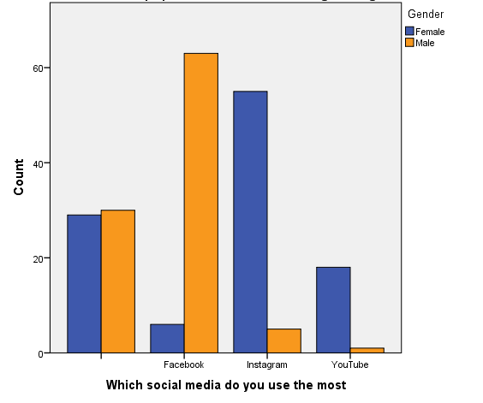
Note: questionnaire item was: “Which social media do you use the most?”

Figure 2: purpose of using social media.
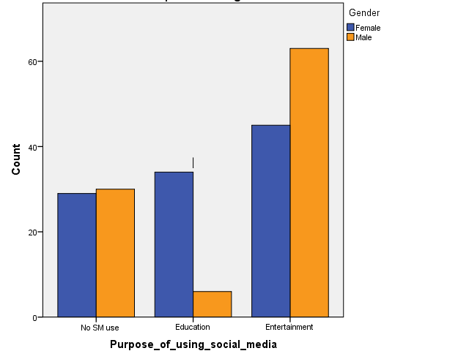
Note: the questionnaire item was “Purpose of using social media”
According to the Figure 2 majority of students who participated in this questionnaire use social media for entertainment.

Figure 3: relationship between gender and quality of sleep.
Note: The questionnaire item was “Rate your quality of sleep”
Majority of male gender have rated 10 as their quality of sleep while majority of females rate 9. This chart includes both students who use social media and who don’t use social media.

Figure 4: association between quality of sleep and hours of sleep
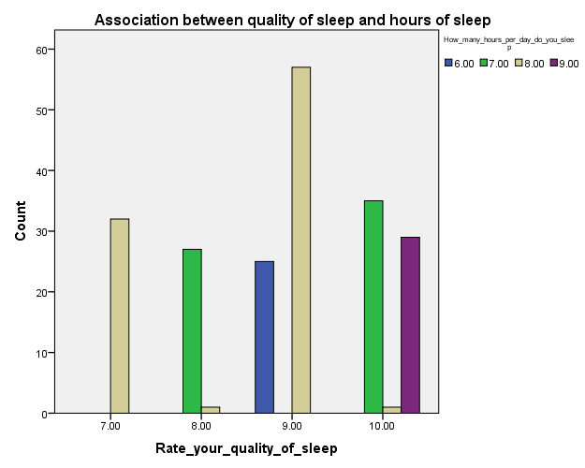
Note: The questionnaire item was “How many hours per day do you sleep”
This chart illustrates the quality of sleep does not depend on the hours of sleep. Students who sleep 8 hours per day have rated 7, 8, 9 and 10 as their quality of sleep. To check the effect on using social media before sleep, we should compare those students and their quality of sleep

Table 1: students who use social media within 1 hour of sleep.
Students who use social media within 1 hour of sleep.
Count
 |  | Do you use social media? |  | Total
 |  | No | Yes
Do you use social media within 1 hour of sleep? |  | 59 | 0 | 59
 | No | 0 | 34 | 34
 | Yes | 0 | 114 | 114
Total |  | 59 | 148 | 207

Table 2: association between using social media before sleep and quality of sleep.
Association between using social media before sleep and quality of sleep
Count
 |  | Do you use social media within 1 hour of sleep? |  |  | Total
 |  | No social media | No | Yes
Rate your quality of sleep | 7.00 | 0 | 0 | 32 | 32
 | 8.00 | 0 | 0 | 28 | 28
 | 9.00 | 28 | 0 | 54 | 82
 | 10.00 | 31 | 34 | 0 | 65
Total |  | 59 | 34 | 114 | 207

According to the table 2, students who don’t use social media before sleep have the highest quality of sleep. 54 students who use social media before sleep have rated their quality of sleep as 9. Twenty eight students have rated 8. In the group of students who do not use social media at all, 31 students have rated their quality of sleep as 10 while 28 students rated 9. This indicates there is no effect in using social media before sleep.

Conclusion

The primary goal of this study, which was to determine using social media before bedtime affects sleep cycle was rationally stated, and the primary research question was satisfactorily addressed. Undergraduate students use social media as a stress releasing method, for educational purposes, because of FOMO, for entertainment purposes. The most preferred social media among undergraduates was Facebook. Majority of students use social media for entertainment purposes. According to the collected data there is no significance impact between the sleep quality of students who use social media and students who do not use social media.

References

Facebook users in Sri Lanka - April 2023 | NapoleonCat. (n.d.).
https://napoleoncat.com/stats/facebook-users-in-sri_lanka/2023/04/

Digital 2023: Sri Lanka — DataReportal – Global Digital Insights. (n.d.).
https://datareportal.com/reports/digital-2023-sri-lanka

Orzech, K. M., Grandner, M. A., Roane, B. M., & Carskadon, M. A. (2016).
Digital media use in the 2 h before bedtime is associated with sleep variables in university students. Computers in Human Behavior, 55, 43–50.
https://doi.org/10.1016/J.CHB.2015.08.049

Wolniczak, I., Cáceres-DelAguila, J. A., Palma-Ardiles, G., Arroyo, K. J., Solís-Visscher, R., Paredes-Yauri, S., Mego-Aquije, K., & Bernabe-Ortiz, A. (2013).
Association between Facebook Dependence and Poor Sleep Quality: A Study in a Sample of Undergraduate Students in Peru. PLOS ONE, 8(3), e59087.
https://doi.org/10.1371/JOURNAL.PONE.0059087

Chen, X., Vorvoreanu, M., & Madhavan, K. P. C. (2014).
Mining social media data for understanding students’ learning experiences. IEEE Transactions on Learning Technologies, 7(3), 246–259.
https://doi.org/10.1109/TLT.2013.2296520

Adams, S. K., & Kisler, T. S. (2013).
Sleep Quality as a Mediator Between Technology-Related Sleep Quality, Depression, and Anxiety. Https://Home.Liebertpub.Com/Cyber, 16(1), 25–30. https://doi.org/10.1089/CYBER.2012.0157

Combertaldi, S. L., Ort, A., Cordi, M., Fahr, A., & Rasch, B. (2021). Pre-sleep social media use does not strongly disturb sleep: a sleep laboratory study in healthy young participants.
Sleep Medicine, 87, 191–202.
https://doi.org/10.1016/J.SLEEP.2021.09.009

Wong, H. Y., Mo, H. Y., Potenza, M. N., Chan, M. N. M., Lau, W. M., Chui, T. K., Pakpour, A. H., & Lin, C. Y. (2020). Relationships between Severity of Internet Gaming Disorder, Severity of Problematic Social Media Use, Sleep Quality and Psychological Distress.
International Journal of Environmental Research and Public Health 2020, Vol. 17, Page 1879, 17(6), 1879.
https://doi.org/10.3390/IJERPH17061879

Levenson, J. C., Shensa, A., Sidani, J. E., Colditz, J. B., & Primack, B. A. (2016). The association between social media use and sleep disturbance among young adults.
Preventive Medicine, 85, 36–41.
https://doi.org/10.1016/J.YPMED.2016.01.001

Levenson, J. C., Shensa, A., Sidani, J. E., Colditz, J. B., & Primack, B. A. (2017). Social Media Use Before Bed and Sleep Disturbance Among Young Adults in the United States: A Nationally Representative Study.
Sleep, 40(9).
https://doi.org/10.1093/SLEEP/ZSX113

Pirdehghan, A., Khezmeh, E., & Panahi, S. (2021).
Social Media Use and Sleep Disturbance among Adolescents: A Cross-Sectional Study.
doi: 10.18502/ijps.v16i2.5814

Alonzo, R., Hussain, J., Stranges, S., & Anderson, K. K. (2021). Interplay between social media use, sleep quality, and mental health in youth: A systematic review.
Sleep Medicine Reviews, 56, 101414.
https://doi.org/10.1016/J.SMRV.2020.101414

Scott, H., & Woods, H. C. (2019). Understanding Links Between Social Media Use, Sleep and Mental Health: Recent Progress and Current Challenges.
Current Sleep Medicine Reports, 5(3), 141–149.
https://doi.org/10.1007/S40675-019-00148-9/METRICS

Kolhar, M., Kazi, R. N. A., & Alameen, A. (2021). Effect of social media use on learning, social interactions, and sleep duration among university students.
Saudi Journal of Biological Sciences, 28(4), 2216–2222. https://doi.org/10.1016/J.SJBS.2021.01.010

Gardani, M., Biello, S., & Woods, H. C. (2016).
Social media use, fear of missing out and sleep outcomes in adolescence. https://www.researchgate.net/publication/308903222

